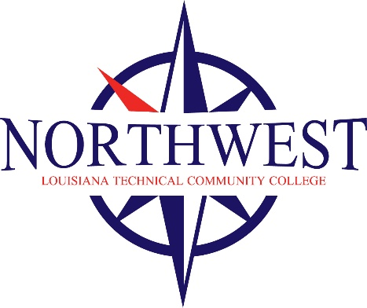

**For immediate release**

Contact: Earl Meador

Chancellor, NLTCC

318-371-3035

[earlmeador@nltcc.edu](mailto:earlmeador@nltcc.edu)

**FOURTEEN STUDENTS AT NORTHWEST LOUISIANA TECHNICAL COMMUNITY COLLEGE SPORTED A ‘COKE AND A SMILE’   
EACH CELEBRATING A $450 SCHOLARSHIP, COURTESY   
OF MINDEN COCA-COLA**

On behalf of Minden Coca-Cola, General Manager, Russell Brown and Controller, Kasi Kendrick, presented the scholarships along with a case of Coca-Cola for each student.  The NLTCC student recipients of the $450 scholarships were: Brandon Toney, Matthew Treece, Tonya Guillot, Laken Bernard, Freda Boiro, India Thompson, Thomas Parnell, Jackie Loyd, Kaylie Wolfe, Justin Jarvis, Savannah Sharpe, Nathan Norwood, Cindy Norment, and Taylor Norment.

NLTCC Chancellor Earl Meador thanked Minden Coca-Cola for the generous scholarships and continued support of NLTCC. Meador said, “Minden Coca-Cola in addition to these generous scholarships they also provide employment opportunities for our students. We thank Minden Coca-Cola for their investment in our students and the future of our community.”

Vice President, Steven Lingenfelter, said later, “Though Minden Coca-Cola awards scholarships each year, this year with the impact of Covid-19 on our area, we are especially happy that we could help these students. We are very proud of what NLTCC has done to enable these men and women to pursue higher learning and better opportunities in the midst of the pandemic. Our community is fortunate to have this campus here. We wish good health and success to this year’s recipients.”

###

*Founded in 1936, Northwest Louisiana Technical Community College is a member of the Louisiana Community and Technical College System. The main campus is located in Minden and other campuses operate in Mansfield and Shreveport.*